My ordering of move_expand_order is 4,0,2,6,8,1,3,5,7 as shown below:



Expanded node count is 42126 as shown below:

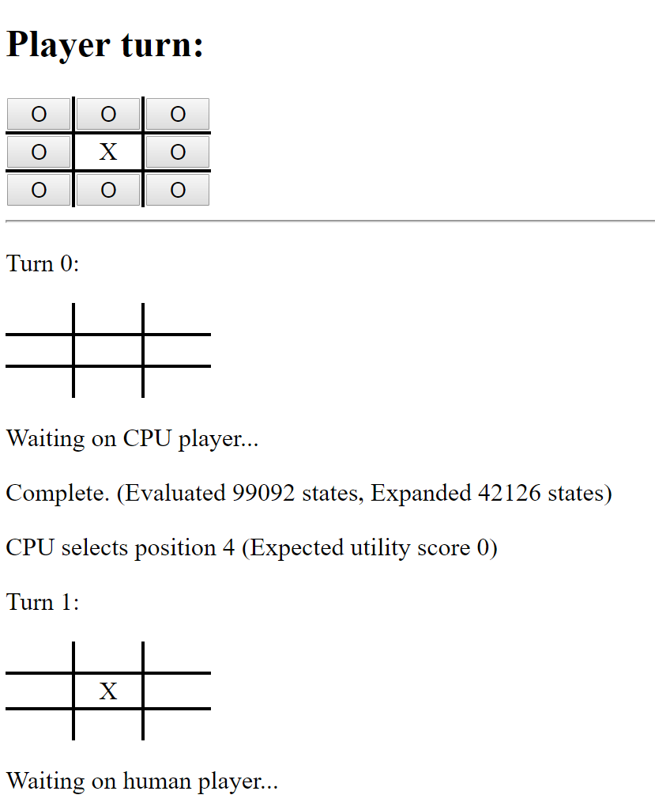

The reason why this order can get the count of expanded states less than 50,000 is explained as follows. I moved the positions, which is more likely to get a larger utility value, in front of the positions less likely to achieve this. Position 4 is the most likely position to win because it can be as one element for 4 possible cases (one row, one column and two diagonals). Then, position 0, 2, 6 and 8 can be as one element for 3 possible cases (one row, one column and one diagonals). At last, 1, 3, 5 and 7 can only make 2 possible cases (one row and one column). So, in this order, the algorithm can quickly get a larger alpha, which is more likely to prune branches.